Job Title:
Build a Dynamic Excel or Google Sheet to Automate Coach Payments (Combat Sports Gym)
Project Overview:
Hi! I'm the owner of Malta Fight Co. (MFC) a combat sports gym located in Malta. We’re implementing a new, performance-based payment system for our coaches linked to membership management software ‘Go TeamUp’. It ensures coaches are paid for their performance whilst guaranteeing a profit for the company on every sale.
There are around 50 different pricing options and for each attendance we need to make sure the right percentages go to the following parties:
- The individual coach delivering the session (we have 11)
- Management team
- Our Landlords – BGM
- The leftover % will be retained by MFC.
The rules are defined in spreadsheet “rules.xlsx” and all coaches names are listed.
The Problem
- The problem is two-fold -
GROUP CLASSES:
- Coaches, our Landlord (BGM) and Managers will all be paid a percentage of revenue generated by each class.
- GoTeamUp can only calculate simple pay rates for coaches based on numbers of attendees
- The class revenue generated depends on the types of memberships used by each attendee
- TeamUp only generates reports for all attendances which includes customer name, class attended, instructor name and booking method (which includes membership data) - we’ll generate this on a monthly basis. This can be found here and we’ll need to generate a new report containing only data from the previous month.
- This report does not contain important information such as how much this member paid for the package which is contained under the column ‘MEMO’.
- There is a separate report containing pay information, we need to match the member’s attendance to the package used AND ensure this corresponds to the latest package they’ve purchased. This can be found here and we’ll need to generate a new report containing ALL HISTORIC data (From 25/03/2025). This sheet will grow indefinitely with time (as we may have customers trying to use packages purchased long ago).

Attendance Data:
Membership Type Used/Coach etc.
Historical Pay Data:
Amount Paid for Membership
+

=
Merged Spreadsheet:
Contains all necessary data

Sample Line from Attendance Data sheet:
Needs to matched with this line in the Historical Pay Data sheet:
We did this by matching the customer’s name fields and the Membership to the Memo field. Then we apply the rules for Adult 10 Pack Pay As You Go:
Divide by 10 to get the cost per class and split in the following ratios:
So for this attendance the following parties got paid:
SFC (18%) | BGM (30%) | Management (8.5%) | Alice (43.5%) (Instructor for this lesson)
€2.02 | €3.36 | €0.95 | €4.88

- Once this report has been compiled, we can calculate revenue per class and then create a report that breaks down:
- Pay for each instructor for that calendar month (ideally with some breakdowns per class/student so they have some information on their payslip on pay per class – or we can atleast provide it to them if they request it)
- Pay for BMG
- Pay our Management team.
2. PRIVATE CLASSES:
- The coach delivering the session will be paid 80% of session revenue and 15% goes to BGM
- Different customers will have paid different rates depending on special offers or discounts
- GoTeamUp can only calculate simple per hour rates for each coach
- The above ‘MERGED’ spreadsheet will contain the required information, we’ll need to be able to distinguish between the private sessions and the group sessions however and apply the private session rules.
Our Ideal Freelancer
You Should Be Skilled In:
• Advanced Excel / Google Sheets formulas (e.g., IF, VLOOKUP, XLOOKUP, INDEX, MATCH, FILTER, etc.)
• Pivot tables or interactive dashboards
• Structuring sheets for non-technical users
• Scripting with Google Apps Script or Excel VBA
• Handling large datasets and dynamic filtering
What We’ll Provide:
• Sample TeamUp exports
• A full breakdown of all coaches, class types, and payment rules
• Clarifications during the build process
• Feedback during testing and revisions
Deliverables:
• Final version of the sheet (Excel or Google Sheets preferred) where I can personally add new packages and tweak percentages if needed in future
• Documentation or short Loom video explaining how to use/update it
• Built-in validation to prevent formula breaks
- Bonus: Automated payslip creation for each party
Timeline:
Looking to get this started immediately and completed ASAP.

Complications/Exceptions
- You will be provided with a rules spreadsheet explaining all the rules for the various packages but we will encounter the following issues…

Sample Rules
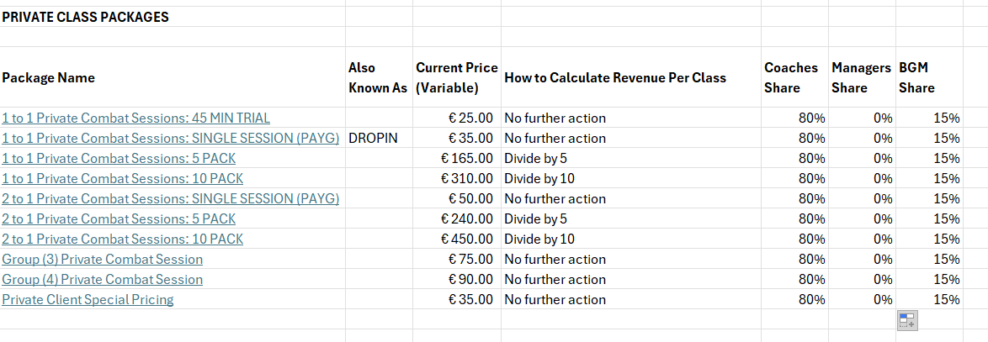
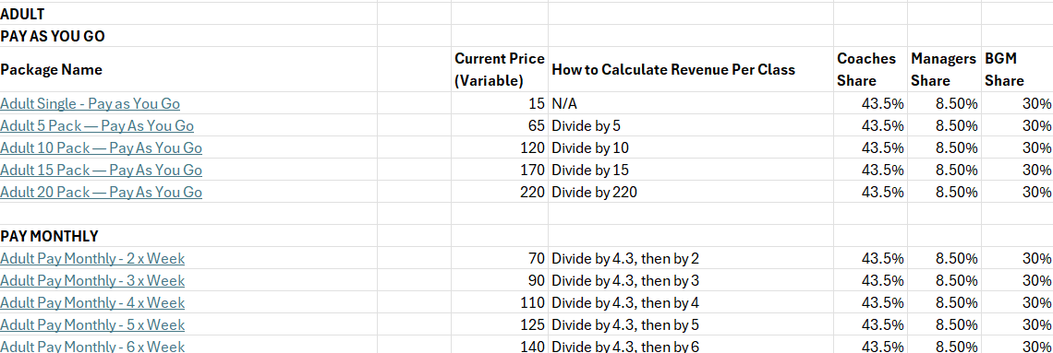

- Kids/Parent Profiles. Packages should be purchased for the child and the child should get booked onto a session. Sometimes parents mistakenly purchase packages under their own names, we usually transfer these afterwards. If the parent books on using their name, the instructor should still get paid the correct amount
- All splits need to be calculated less 7% tax. The ‘fee’ section contains taxes, so most lines actually include the price we need which is membership less tax.
- Refunds: In this case, Alex Salazar’s mother purchased the wrong package, this was refunded and then chose a cheaper package:
We shouldn’t have an issue as the 10 pack was not used and the 5 pack was selected as the membership option during his attendance on
- Certain packages have been applied for ‘FREE’. You’ll notice there are two lines:
The positive amount is correct and what the customer should have paid. We will base coaches pay on what the customer should have paid.
*Why?* For two reasons:
1. Customer data was moved from another app during March/April, so the transaction records are not held by GoTeamUp. We moved over the membership information but not the payment data. When applying the memberships however on the new system, there should be the same amount that was charged to the customer so this shouldn’t affect us too much.
- Certain packages will have discounts applied to them and we need to be able to calculate the class cost including the discount. All discounts have now been amended to have the word DISCOUNT in the subject. Old discounts that don’t have the name ‘discount’ in the subject are (Summer School: 7 Weeks, SUMMER ACADEMY LOYALTY SCHEME, FORTNIGHT SPECIAL, FEEL GOOD MEMBERS, EVOLVE COLIVING)
- Any Memo containing ONLY the word ‘fee’ can be ignore – these are sales taxes (7%)
- Duplicate customers/multiple profiles may cause difficulties matching attendances to membership purchases. We should match to the latest membership with a matching name (the purchase date may also be after the class if the customer was in arrears).
- Customers can pay with single sessions – easy, multipacks – we’ll need to divide the multipack by the number of classes, or sessions per week – we’ll have to count the total number of sessions per month based on a 4.3 week average.
- Payment rules require updating as we add new payment structures – we’ll need to be able to make these amendments and add new packages as time goes on.
- Certain classes have a ‘drop in function’ which has now been disabled, it means that instead of the membership package name, the ‘memo’ states the name of the class here. Examples include (WARRIOR FLOW (date/time), YOUTH BOXING (13 - 17) (date/time), KICKBOXING: DRILLS (date/time)

Thanks!
Jay Rajakariyar
Owner — Malta Fight Co.

